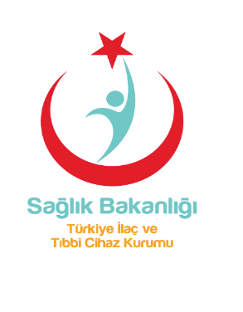

THE REPUBLIC OF TURKEY
MINISTRY OF HEALTH
(Turkish Medicines and Medical Devices Agency)

Date of issue: 7 May 2012

TO WHOM IT MAY CONCERN

HEALTH CERTIFICATE
Free Sales Certificate

Medical devices, which are in the scope of 93/42/EEC Medical Devices Directive, listed additional page(s), produced by the manufacturer called “……TİTUBB’da kayıtlı üretici adı…” ( ….Adres….)can be freely sold in Turkey and European Union and exported to other countries.

This certificate expires after 12 months from the date of issue.

Sincerely Yours

Ercan ŞİMŞEK, MD.
Vice President

LIST OF THE PRODUCT

End of Product(s) List
7 May 2012

Turkish Medicines and Medical Devices Agency 06520 Çankaya-Ankara-TÜRKİYE
Phone:+90 312 218 30 57 Fax: +90 312 218 30 59 Note:Please determine the section code, reference number and date in your answers
http:\\www.iegm.gov.tr

